**(a) Analysis of External Data Points to Onboard Asia’s Mass Affluent Clients**

**Analysis by One’s Working Profession and Length of Career**

We believe that in identifying potential Mass Affluent clients (net worth of 0.8 million USD to 2 million USD), the 2 most important drivers will be the nature of the individual’s profession and the length of his / her career.

*1st Driver: Working Profession*

Working profession is defined by our group as an individual’s employment with a firm or a self-employed individual. For an individual’s employment with a firm, we will be extensively using the 2018 Hays Asia Salary Guide for the analysis by different profession categories and the corresponding average annual salaries across Asia. The countries studied in the research are China, Hong Kong, Malaysia, Japan and Singapore.

Table 1:



From the team’s analysis of the 2018 Hays Asia Salary Guide, we have identified 4 categories of broad working profession and the corresponding average annual salaries in Asia (Table 1): For Accountancy & Finance, the average annual salary is at 67,000 USD. For Manufacturing & Operations, the average annual salary is at 40,000 USD. For Information Technology, the average annual salary is at 69,000 USD. For Construction & Engineering, the average annual salary is at 85,000 USD. Thus, the data implies that certain professions that pay more, such as Construction & Engineering, will require a shorter career length to attain the minimum net worth of 0.8 million USD and vice versa.

*2nd Driver: Length of Career*

Given the above results, we extend it further by considering each country’s propensity to save. According to HSBC’s Future of Retirement Survey in 2013, the propensity in China is at 48%, Hong Kong is at 60%, Malaysia is at 46%, Japan is at 50% and Singapore is at 59%. We factor these percentages in our calculation. Given our assumption that an individual’s net worth is determined by their savings and Asian individuals on average begins their career at the age of 22, we can work out the average career length for each general profession across Asia given the target net worth of 0.8 million USD. From Table 1, we can thus conclude that Mass Affluent Clients are most likely to come from individuals across the age of 40 to 50 in the general professions of accounting & Finance, Construction & Engineering and Information Technology.

*Technology to Account for the 2 Drivers*

The database that we can use is professional networking sites such as LinkedIn. As individuals are likely to update their employment status, EB can do a key word search on ‘Accounting’, ‘Finance’, ‘Information Technology (IT)’ and ‘Engineering’. Also, EB would want to use the AND criteria in the key word search for LinkedIn to identify individuals who have been on a career path for more than 18 years. EB can attempt in Facebook by using the AND criteria to identify individuals who are around 40 to 50 years old.

**Analysis by an individual’s Monetary Contributions to Charity Organisations**

According to numerous studies, wealthy individuals are more likely to donate as compared to those who are less wealthy. The incentive to donate comes from various sources, such as tax breaks, altruistic reasons or a cause that the donor believes in. Our team believes that Mass Affluent clients can be identified from donors who made a significant contribution to charity organisations and have their names mentioned in the significant donor’s list. Also, from the amount donated by the individual, we can set a minimum threshold for the donated sum which could indicate, in high probability, a donor with a net worth of at least 0.8 million USD.

*Analyse Medium to Large, Well-established Charity Organisations*

**Philippines –** Maharlika Charity

**Hong Kong** AIDS Foundation



**Malaysia** – The Budimas

**China** – One Foundation

**Singapore** – National Kidney Foundation

Large and well-established charity organisations such as the ones listed above regularly publish their annual reports. This report usually will contain the names of significant donors. Our team believes that this will be an excellent indication of relatively high net worth individuals because to qualify as being mentioned in the annual report, it signifies a large sum of money being donated from the individual.

*Asian Donors usually donate at a sum estimated to be 2.5% of their gross income*

According to the Money section of Time Magazine in 2012, individuals coming from different income brackets give donations of differing percentages, with no trend that can be discerned. From our group’s analysis, the average percentage of gross income donated is around 4%. Given that Time Magazine is Western-centric and Westerners tend to save less than Asians, we should reduce this percentage to around 2.5%.

Performing a simple calculation:

To have a net worth / savings of at least 0.8 million USD and an average propensity of Asians to save at 53%, the computed gross annual income is = 0.8 M / 0.53 / ((18 years + 28 years) / 2)

= 65,628 USD

Thus, the minimum annual amount donated on average should be = 65,628 x 0.025

= 1,641 USD

*Technology to Account for Large Charity Organisations and Quantum Amount*

The external data that we can use is the annual reports published by large charity organisations. We can upload a library of large charity organisations names and run an analysis on these annual reports to extract the name of individuals who cumulatively, donated a minimum amount of 1,641 USD over the entire year. These names will then be analysed for duplicates against our internal client database and for duplicated names across multiple organisations. The latter may imply an individual who donates large sums of money to multiple charity organisations, thus raising the odds of being a potential Mass Affluent Client for EB to onboard.

**(a) Internal: Analysis of Internal Data to Identify Asia’s Mass Affluent Clients**

The application of data analytics and business intelligence tools can provide valuable, actionable insights in targeting and identifying new prospects for EB’s expansion in the mass affluent banking market. Such a strategy will require making sources of internal data across EB readily available for analysis and the means to which such data can be used towards.

**Unlocking Internal Data Across the Organisation**

For the application of analytics to be effective, data must be readily available. As such, the data must be available to the users and applications performing analysis to identify prospective mass affluent clients in Asia. Such data should be digitised and stored in databases which are accessible on demand.

EB has a wealth of data on its existing customer base. This information can be leveraged upon to enable better prospecting and making of business decisions. There are two critical sources of data which can provide valuable information for identifying new mass affluent banking prospects in Asia. The first is the individual banking data of existing customers, not only in the mass affluent category but also the high net worth and ultra-high net worth. The second is the wealth of information being collected for compliance purposes due to the trend of increasing demands on anti-money laundering (AML) and anti-terrorism financing requirements.

1) Individual Banking Data and Transaction History

Several data points can be obtained from this source. First, there is individual banking data will include information on wealth management products bought into and the duration clients stuck to those products. Second, there is transaction history, such as loans taken out and the nature and purpose of the loans.

This data tends to be highly digitised and the key challenge is to ensure that there is availability of information on demand across different segments of customers (mass affluent, high net worth, ultra-high net worth) and the various regional offices. Teams and divisions involved in the planning and execution of strategies to expand EB’s mass affluent banking segment in Asia must be given access to the information and have a feedback process on how the information can be better structured, stored and expanded for the purposes of analysis.

2) Compliance Details and Documentation

Compliance requirements already require EB to collect documentation on a variety of areas. Of these areas, two stand out in immediate importance in the process of finding new prospects in the mass affluent banking segment. The first is information on the individuals related to the current clients and the second is sources of wealth. This information can directly lead to new prospects by identifying people related to wealthy individuals and placing attention on people who run or work for businesses which are identified as sources of wealth for other mass affluent and high net worth clients.

The challenge when it comes to analysing compliance data is its high variety due to the different sort of documents being collected. Properly structuring such data is critical for information to be effectively used for analysis. EB must look at the different regulatory and compliance requirements of the different regions and study the kinds of documentation the compliance functions have collected in the past to categorise information in a meaningful way. This will allow information, such as related parties and source of wealth to be obtained from compliance information.

**Use Cases for Identifying Prospective Mass Affluent Banking Clients**

With internal data made available, there are several ways in which the data can be mined for information and insights to inform and monitor the expansion into the mass affluent banking market in Asia.

1) Providing Insights for Marketing Campaigns

EB will likely seek to engage in marketing campaigns to reach out to new mass affluent banking customers. Data from other clients can help in informing the best marketing channels and methods to reach out to mass affluent clientele.

One example of how this can be performed is by looking at existing high or ultra-high net worth clients who would be classified as be mass affluent banking clients some number of years ago. Their past banking history with EB, such as the wealth management products bought, will inform on the priorities these individuals would have as mass affluent clients at a younger age and wealth level. Marketing and advertising campaigns which are targeted at clients of those ages can then be improved as knowledge of priorities, such as savings levels and risk profiles, will allow the relevant products offered by EB to be emphasised.

Another example is looking at transactions of other mass affluent clients, such as loans for luxury cars, house purchases and travel plans to inform EB of areas of interest. EB can use this information to obtain clear up to date information of the preferences of such clients to target their marketing campaigns more effectively. In this case, knowing that mass affluent clients are engaged in buying luxury cars or homes can enable advertisements to target potential clients of mass affluent banking services on relevant websites and events. This will enable better statistics backed idea generation in driving brand and engagement to the mass affluent banking client base in Asia.

2) Prospect Generation via Internal Data

Compliance requirements has required EB to collect more information on its own clients, such as the identities of family members and friends as well as the job functions and industries which are filled with people from the mass affluent wealth bracket.

By achieving accessibility to the data available within compliance documentation, EB can apply analytical methods and algorithms to sieve out the names of individuals as well as jobs and industries which are highly indicative of being in the mass affluent banking wealth bracket. The information can then be presented to the Client Advisors (CA) who will assess and reach out to the prospects.

3) Complementing External Sources of Data

Internal data can be used to complement externally gathered sources of data. This allows EB to solve the problem of veracity of data faced by strategies driven by external data. Externally gathered data is subject to high amounts of uncertainty due to their nature since they come from low consistency sources, such as social media, or low information formats, such as charity listings. Internal banking data on the other hand is by its very nature much more certain and accurate due to the demands of the industry and regulations.

Internal data can thus be used to supplement or confirm the findings of external data and information to allow decisions to be made with a lower degree of uncertainty. For example, after identifying major donors from public, externally gathered listings made by charities, the identified donors can be searched for in EB’s existing client base. The matches can then be used to see if the thesis was accurate and if adjustments need to be made.

**(b) 2. OPERATIONS**

**2.1 Present Situation**

With access to a recent internal process review of the client onboarding procedures, our team seeks to leverage technology to improve upon the long account opening duration for clients and tackle challenges faced by internal parties involved in the onboarding process. Considering Elite Bank’s (EB) strategies to grow its market share by spearheading Asia Pacific (APAC) Wealth Management (WM)’s venture into the fast-growing Mass Affluent market, cost efficiency improvements through restructuring client onboarding procedures will be crucial in supporting demands generated by this rising business segment while at the same time improving client experience.

**2.2 Current Inadequacies**

Current inefficiencies in the onboarding process bring about long turn-around time for account opening with huge number of backlogs in the Middle Office, especially affecting Know-Your-Clients (KYC) department. Long information processing time because of a lack of an established communication channel between Front and Middle Offices leads to unclear status of events and sometimes unexplained rejection of submitted documents. Furthermore, high dependency of the entire onboarding team on manual data entry and paper-heavy document submission methods result in high vulnerability to frequent regulatory breaches and document misplacement hiccups. Mismatch between client’s risk profile and their chosen products do occasionally occur. The absence of a proper document submission protocol also denotes that the onboarding process is often plagued by incomplete or missing documents.

**2.3 Design Philosophy**

Our team grounds the restructuring of client onboarding procedures and design of a technological complement on solving current inefficiencies laid out in Section 2.2. A total of 6 bottlenecks and redundancies in the existing process are carefully identified and a new radically streamlined flowchart is proposed and evaluated. Top priority is placed on installing controls within the new process to aid compliance with local regulatory requirements, given that client onboarding is highly regulated in most countries. This means controls need to be receptive to government regulatory changes, as well as remain adaptable across multinational regulatory bodies. Some control failure scenarios are explored, highlighting the consequential operational risks, and fail-safe measures in the form of human interventions are introduced as necessary within the process design. Maintaining a key focus on these areas ensures an integrated approach to a solution that recognises business, regulatory and technological imperatives.

**2.4 Design Approach**

Applying Dieter Rams’ well-known principles for good design and system thinking, our team has adapted the philosophy to the context of APAC WM’s present situation:

1. **Simplicity –** The client onboarding procedures should be as streamlined as possible. It should not be burdened with redundancies and repeated taskings (such as static data entry). Likewise, the technological solution should maintain an unobtrusive layout and clean user interface – intuitive to use and self-explanatory.
2. **Adaptability –** The client onboarding procedures need to maintain multinational flexibility given region-wide implementation under APAC WM department. The technological solution should be built with existing system implementations in consideration (such as established SQL databases), reducing adoption barriers while maintaining backward compatibility.

**2.5 Proposed Solution to existing bottlenecks and redundancies**

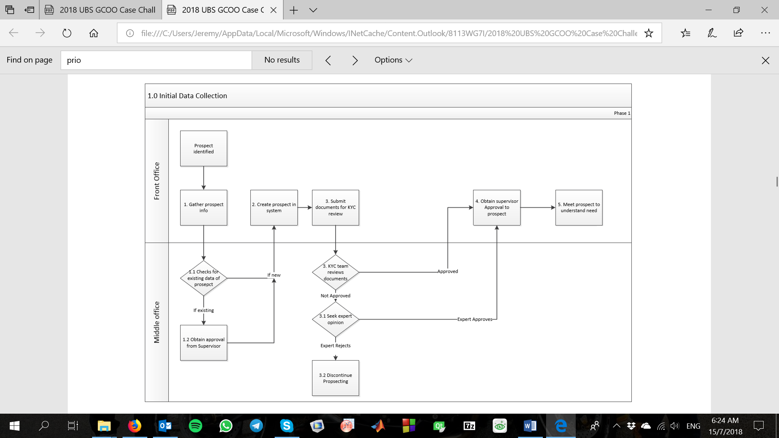

3

1

2

***Radical Change No.1:*** Redundancy identified in role of Middle Office performing personnel identification search in EB’s database for checking of conflict of interests for new client prospect. This manual task can be handled automatically through a software database system that allows Client Advisors (CA) from Front Office to immediately alert Desk Head/Country Team Head for approval should the prospect be identified as existing customer upon entering their personal details.

***Radical Change No.2:*** Feedbacks from the ground criticise the lack of a clear communication channel between KYC and CA, creating necessary confusion and delays in the onboarding procedures. We propose integrating the software database system with a shared portal for the entire APAC WM department. The proposed portal will be built with a “message” function that allows KYC to inform CA of errors in submitted documents or missing information in the prospect’s profile. The status of the prospect’s onboarding will also be updated in real-time, so CA can give confident replies to duration enquiries from prospective clients.

***Radical Change No.3:*** With clear responses from the KYC and real-time updates on prospect’s onboarding status, CA can expediate their meetings with the prospect to compile their financial goals and needs, reducing the waiting time in the onboarding process. CA should concurrently prepare prospect’s Investor Profile (IP) and compile their financial products chosen. This allows the Supporting Function team’s evaluation of IP and risk tolerance with the financial products chosen to also be expediated (see *Radical Change No. 6*).

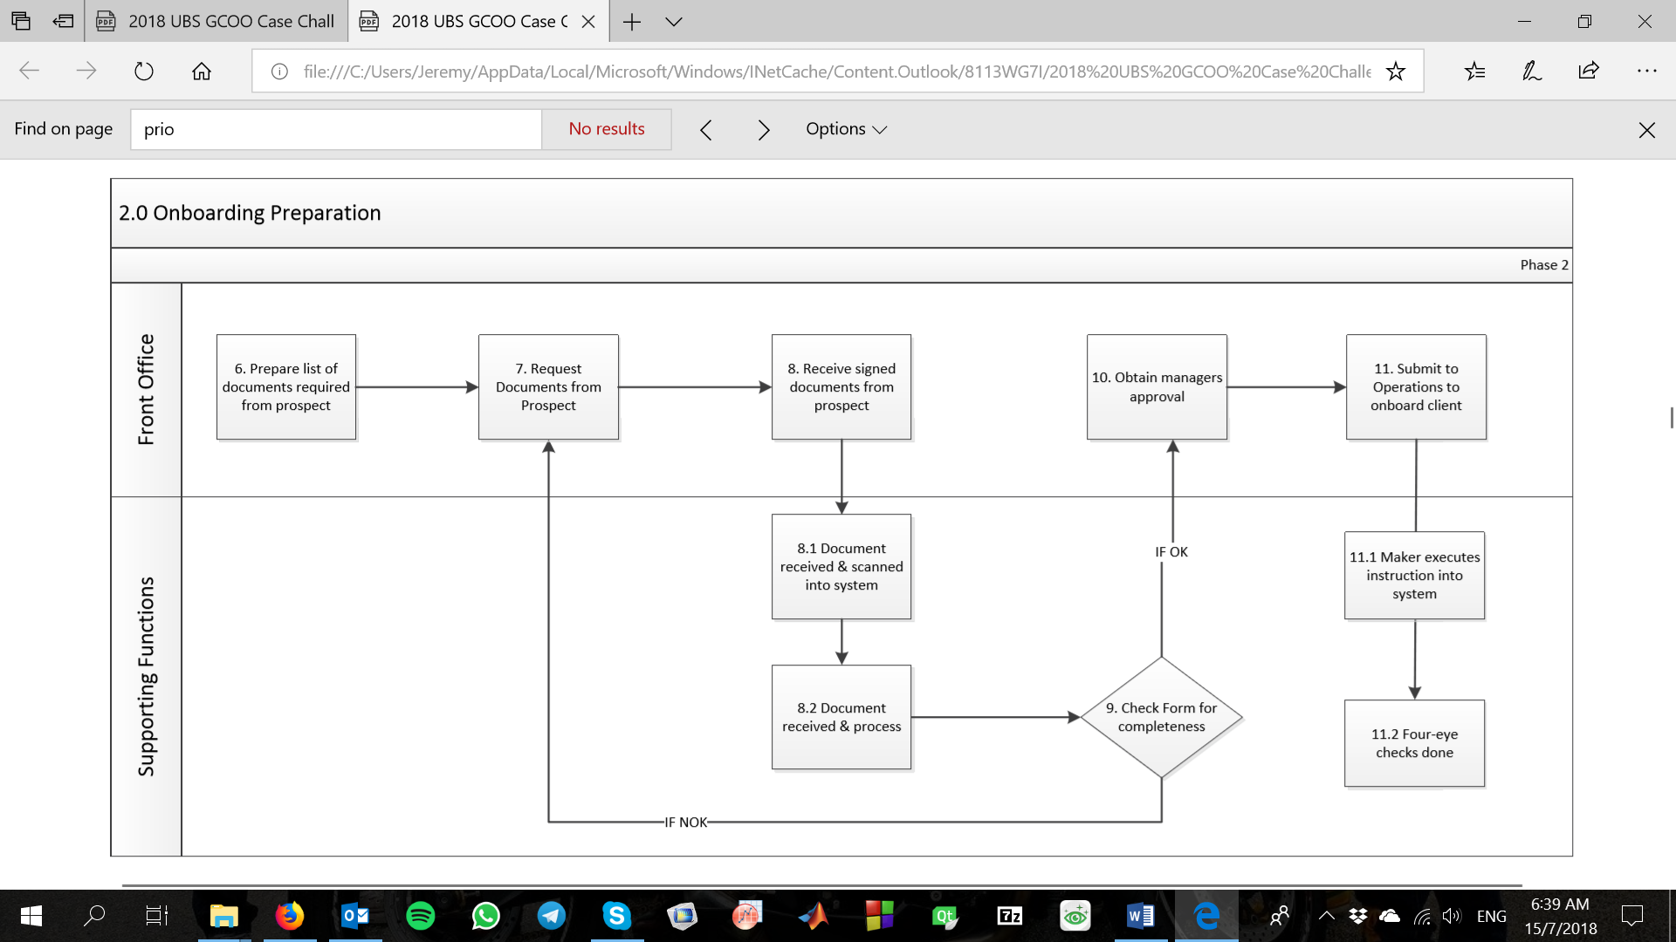

4

2 repeated

5

***Radical Change No.4:*** The database portal will be built to accept the upload of prepared documents from CA for review by KYC. This circumvents the existing paper-heavy document submission methods that are prone to misplacement hiccups – reducing long term exposure to operational risk for failure to retain required KYC client information throughout the life of the business relationship.

***Control Measures:***In compliance with local government regulatory requirements at this juncture, control measures in the form of a guideline and checklist (Appendix A) should be drafted for CA to aid them in procuring the necessary documents from the prospects for submission. This guideline should be drafted by the legal team and should be country-specific to ensure absolute compliance with local regulations. Such guideline and checklist also eliminate the potential for CA to submit less than the necessary required documents.

***Control Failure and Exposure to Operational Risk:*** While a guideline and checklist can serve as good parameters for determining the relevant amount of information needed from a prospect, not all prospective clients can be neatly classified into well-defined categories because of dynamic business environments. Owners of small businesses for example, may not be able to produce the necessary official documents and can potentially be written off as prospective clients with an overly cautious guideline and checklist. A less stringent guideline and checklist will, on the other hand, be unwillingly tolerant towards prospects with questionable businesses and backgrounds. CA may also have vested interest regardless of guideline and checklist stringency, onboarding as many clients as they can to be better evaluated in their performance matrix, potentially exposing the bank to further operational risks.

***Fail-safe Measures:*** Human intervention is introduced as a mitigation measure to curb this control failure scenario, with the responsibility ultimately falling on both KYC and managerial team. KYC will conduct their client-due-diligence (CDD) check and submit their findings and recommendations to the managerial team using the proposed portal. The manager will play the role of a checker to KYC’s recommendations, establishing a four-eye check that maintains accountability in the onboarding of a prospective client.

***Radical Change No.5:*** Redundancy identified in the role of Account Opening Team performing onboarding duties of a client into the bank’s system. This manual task can be absorbed by the proposed portal, automatically generating the client account profile after the manager approves of the prospect’s CDD checks.

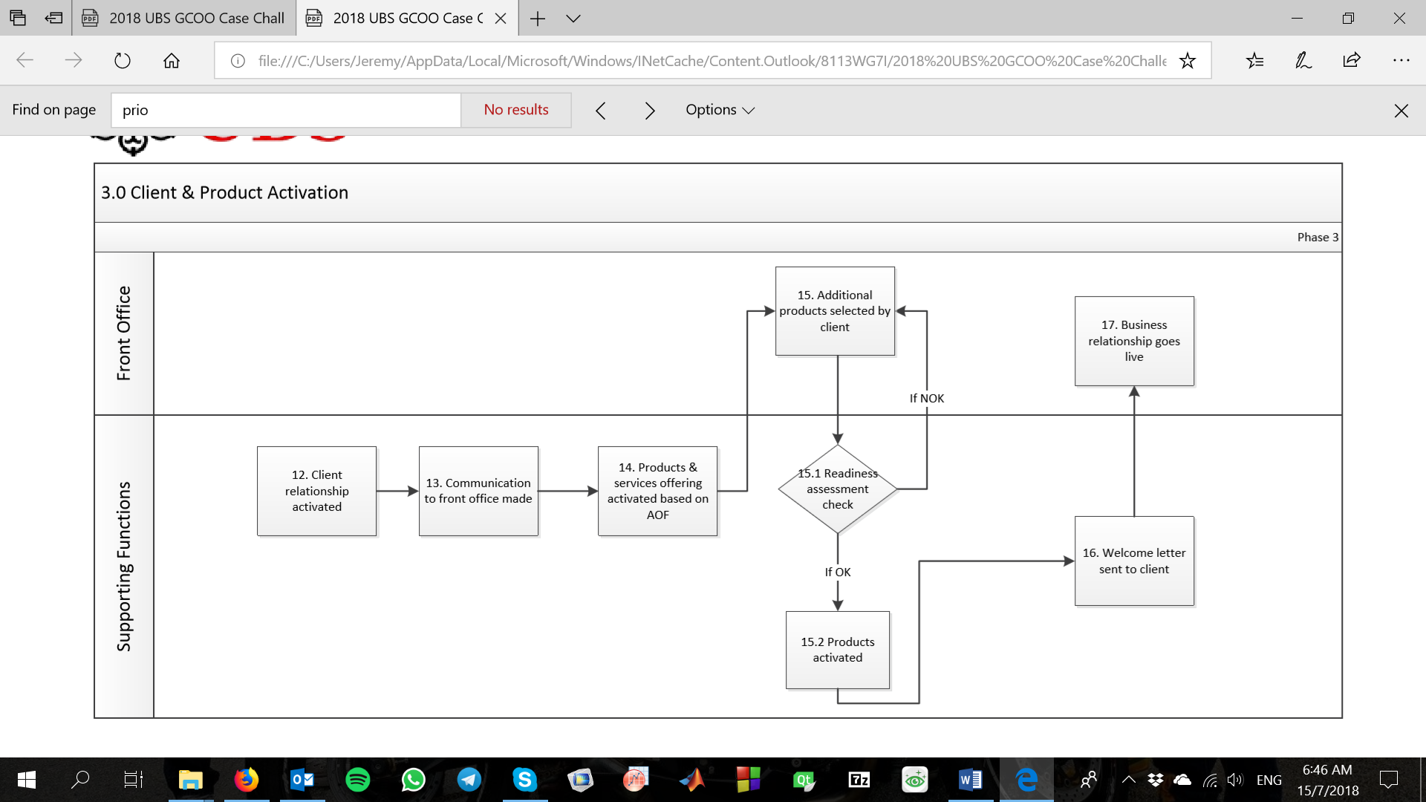

6

***Radical Change No.6:*** Readiness assessment checks by Supporting Function to ensure client’s investor risk profile matches their products chosen can be expediated earlier in the flowchart (see *Radical Change No.3*), even conducted concurrently with the CDD checks by KYC. Similar control measures, failure scenarios, and fail-safe measures (Appendix B) apply at this juncture exactly as they have under *Radical Change No.4*.

**2.6 Overview of Streamlined Onboarding Process**

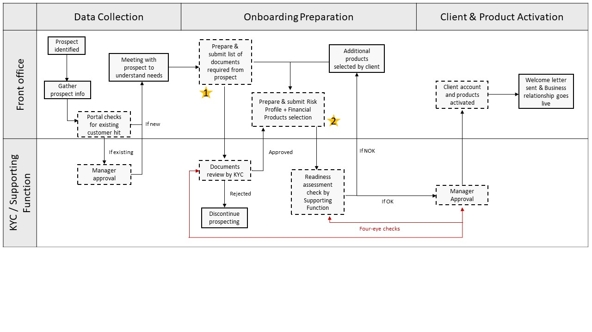

Figure 1. Flowchart showing streamlined client onboarding process

Figure 1 illustrates the redesigned client onboarding procedures, with the digital portal forming an integral component in the entire onboarding process (represented by events in dashed boxes). The yellow stars indicate the different control measures built into the onboarding process:

1. Personnel Document(s) guideline & checklist (Appendix A)
2. Client Risk Profile and Products Selection table (Appendix B)

The red relationship arrows specify parties involved in Four-eye checks as additional accountability of actions to mitigate situations where in-built control measures may fail.

**2.7 Database integrated portal**

Our team designed the portal to interact with existing database in EB. This meant building the portal with SQL querying functions to exploit the well-established software infrastructure and leveraging experienced industry applications. IT technicians could work to develop and maintain the portal without additional training of skills. We decided to construct the program as a localised Windows Desktop executable instead of a webpage to reduce dependencies of the onboarding process on trivial external factors such as Internet connection strength. Creating it as a Windows executable using the powerful C++ language also meant leveraging the vast Windows system libraries that makes the program easily scalable in the future, while maintaining the ability to optimise for speed if required, both of which are paramount to the operations of a bank. A graphical demonstration of the Clientele Portal Prototype 1.0 is given in Appendix C. A download link for the working prototype is also given at the end of Appendix C.

**(c) Workspace and Facilities Strategy:**

Given the overhaul that our team has done by making some processes more automated, we predict that the year on year incremental projection of headcounts can be shaved by a third. This is because as more processes are automated and documents digitized, the number of manual labourers in the KYC check can be reduced. Thus, we pare down the projections in 2018 to 701, 2019 to 848, 2020 to 870 and 2021 to 908. Based on the revised projections, we can calculate the most cost-effective lease option. One assumption that our group has made: Only the comparative increment in workers from year 2017 (675) to year 2021 (908) will be considered in the planning of the area and space in the new facility.

**World Financial Centre**

**Expected Cost of lease calculations:**

Total number of additional manpower = 908 – 675 = 233 people

Number of floors required = 233 / 100 sqft = 3 floors

Total Management Fee = 3.6 USD / sqft / year x 9574 sqft x 3 floors = 103,399 USD

Total Rental Cost = 33 USD / sqft / year x 1.02 x 9574 sqft x 3 floors x (10/12) = 805,652 USD

Total Annual Cost of Lease = 805,652 + 103,399 = 909,051 USD / year

*Conclusion - Most expensive*

**Flexibility of lease terms:** Most flexible because the lease term is based on every 5 years and the renewal and surrender notice can be done within 3 months. However, future expansion is limited to only 1 more floor.

**Pros:** At Central Business District (CBD) and the office is of premium grade A quality. It is just above the train station which makes commuting for workers convenient and has parking spaces for workers who drive. Also, the place is already furnished and is ready for lease as it was completed in 2003.

**Cons:** Too much frills such as a rooftop garden which hiked the cost of renting; The expected total annual cost of lease is nearly 3 times of LKR tower and Marina Business Park. Also, should EB terminates lease, any damage to the space due to the shifting of bulky items like servers and database equipment will cost EB more.

**LKR Tower**

**Expected Cost of lease calculations:**

Total number of additional manpower = 908 – 675 = 233 people

Number of floors required = 233 / 170 sqft = 2 floors

Total Management Fee = 1.5 USD / sqft / year x 14,337 sqft x 2 floors = 43,011 USD

Total Rental Cost = 13.75 USD / sqft / year x 1.01 x 14,337 sqft x 2 floors x (9/12) = 298,658 USD

Total Annual Cost of Lease = 298,658 + 43,011 = 341,669 USD / year

*Conclusion - Much less expensive than World Financial Centre*

**Flexibility of lease terms:** More flexible because the lease term is over 7 years and the renewal and surrender notice can be done within 6 months. Expansion is the most flexible (up to 4 floors) and can allow an increase in manpower significantly should EB requires it in the future.

**Pros:** At CBD area and is a convenient 10-minute walk away for workers from the train station. The amenities are also basic, which reduce the cost of rent drastically. It is also a building ready for rental as it was completed in 2010. Also, there are ample space left on the second floor for manpower or server addition. There is no need for reinstatement when EB leaves, which makes it less costly if it chooses to terminate the lease.

**Cons:** There are no parking spaces for workers who drive and other well-known banks are competing as well.

**Marina Business Park:**

**Expected Cost of lease calculations:**

Total number of additional manpower = 908 – 675 = 233 people

Number of floors required = 233 / 420 = 1 floor

Total Management Fee = 1.8 USD / sqft / year x 32,982 sqft x 1 floor = 59,368 USD

Total Rental Cost = 7.5 USD / sqft / year x 1.015 x 32,982 sqft x 1 floor x (11/12) = 230,153 USD

Total Annual Cost of Lease = 230,153 + 59,368 = 289,521 USD / year

*Conclusion - Least expensive*

**Flexibility of lease terms:** Least flexible because the lease term is over 10 years and the renewal and surrender notice must be a minimum of 6 months. Expansion is the least flexible but it is not a big factor because the floor can still cater to 187 more workers should EB underestimated its manpower needs at the outset.

**Pros:** Large space to house operations equipment such as database servers. The expected cost of lease is the lowest among the 3 facilities.

**Cons:** It does not offer any renewal after 10 years. Moreover, it is quite inconvenient as shuttle bus would probably have to be catered to transport the workers, and this will raise the expected cost of lease on Marina Business Park. One of the biggest cons is that the building will only be competed on July 2019, and the workers will have to enter the new facility by January 2020. Thus, our group thinks that 5 months for renovation is a very tight timeline and the stipulated deadline might be challenging to meet.

**Ultimate Choice – LKR Tower**

In conclusion, we feel that LKR Tower will be the best choice considering all factors. Compared to World Financial Centre, although it has less frills, the frills of World Financial Centre are a little unnecessary and excessive. Given this, LKR Tower can be obtained at a third of the cost of World Financial Centre and still enjoy the convenience of being in the CBD. Compared to Marina Business Park, although LKR Tower is more expensive, it is only by a marginal 50,000 USD. Our team believes that the benefits of CBD area, a more flexible lease term and an already done up facility ready for rental in LKR Tower outweighs the cost savings of 50,000 USD and the excessive space that Marina Business Park can offer. Thus, LKR Tower is our choice.

**Move In**

**Finish Renovation**

**Timetable for the Fit-out Process:**

**Tendering Process**

**Construction and Renovation**

**Approval**

**15 July 2018**

**1 November 2019**

**1 January 2020**

**15 January 2019**

**15 November 2018**